CS-340 Client/Server Dashboard
Project Two
James K Kofa
December 10, 2025

CS-340 Dashboard Screenshots

Mountain_1.png
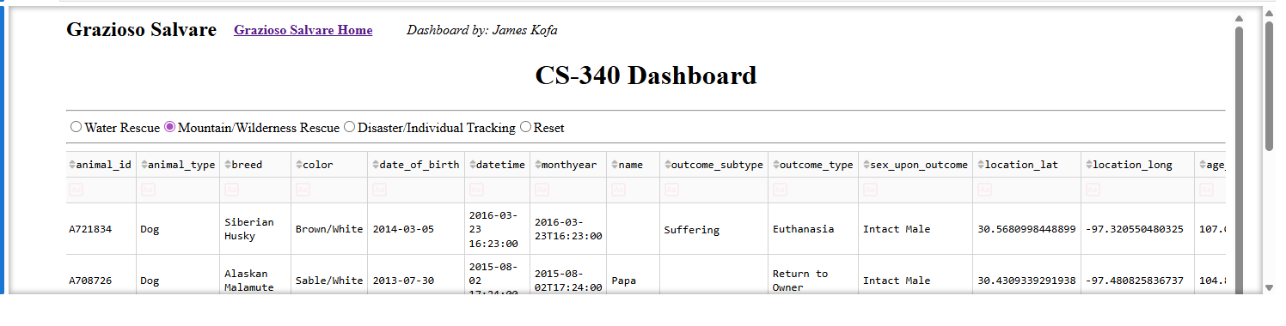
Mountain_2.png
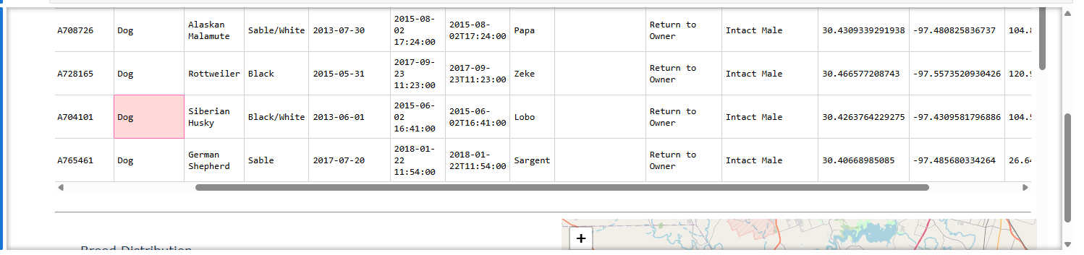
Mountain_3.png
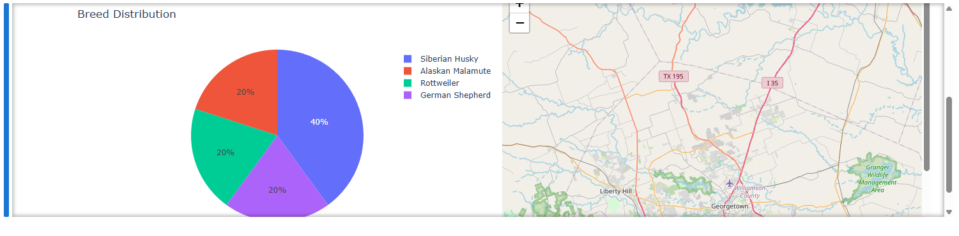
Mountain_4.png
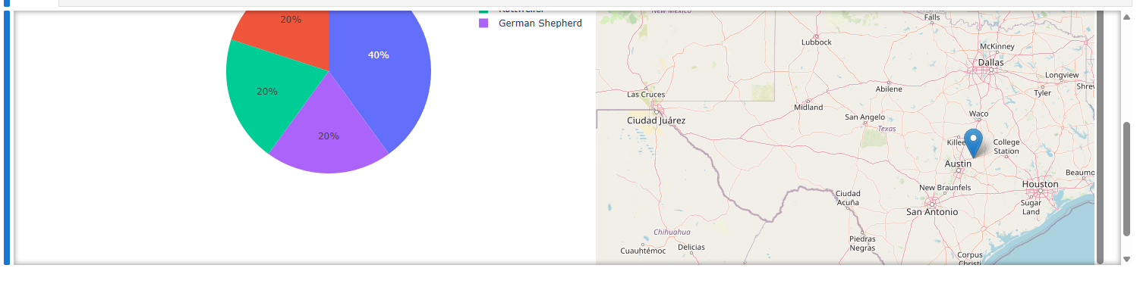
Disaster_1.png
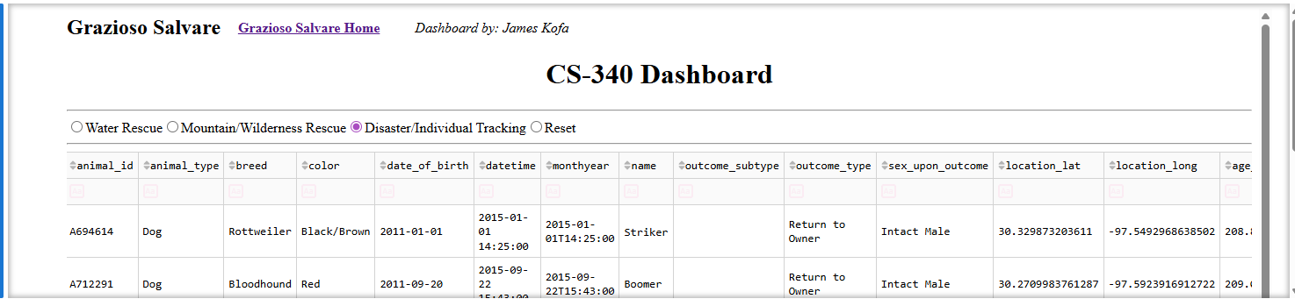
Disaster_2.png
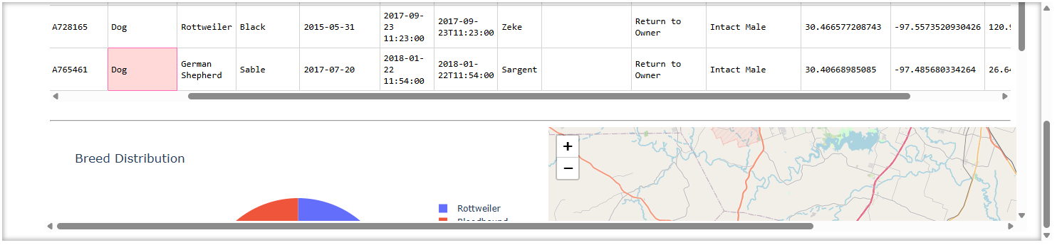
Disaster_3.png
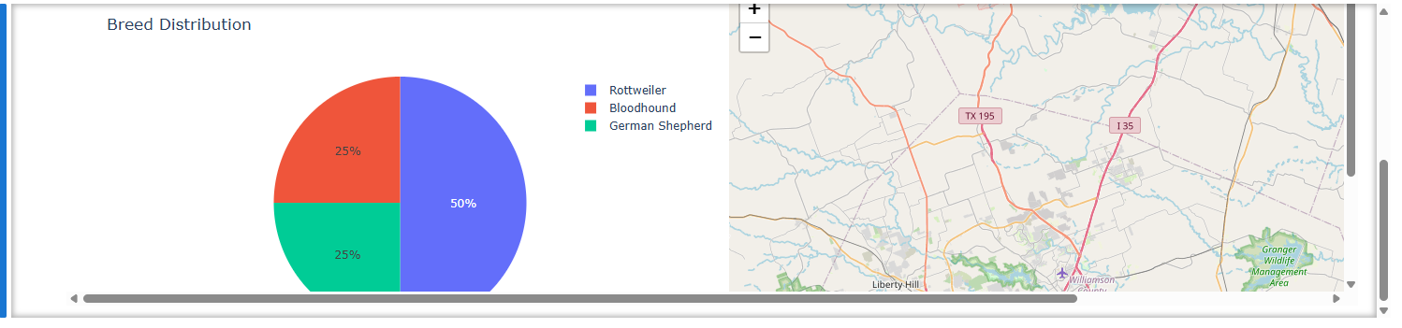
Disaster_4.png
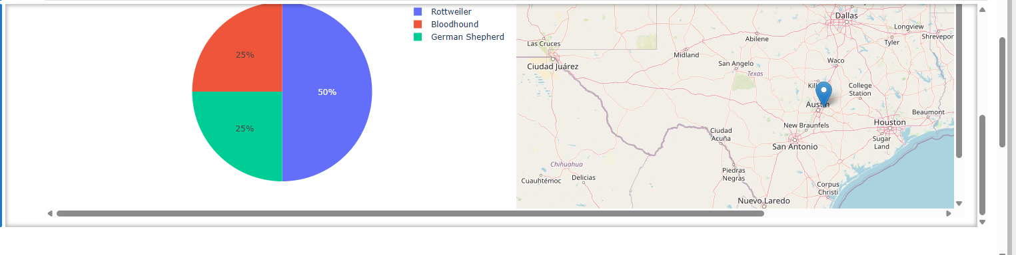
Water_2.png
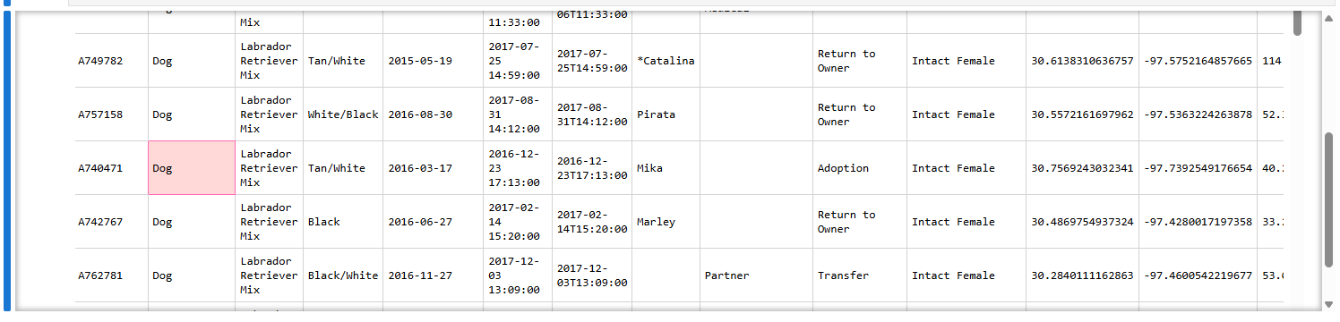
Water_3.png
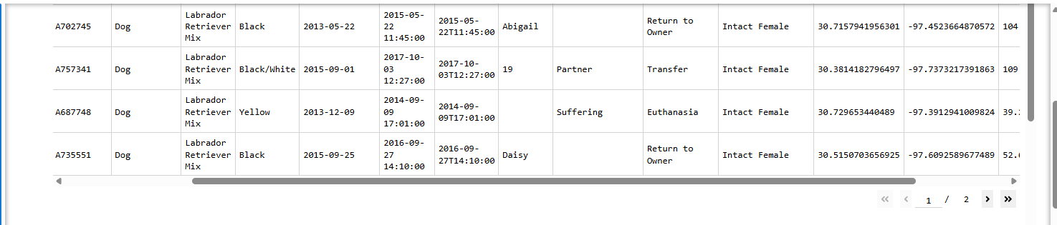
Water_5.png
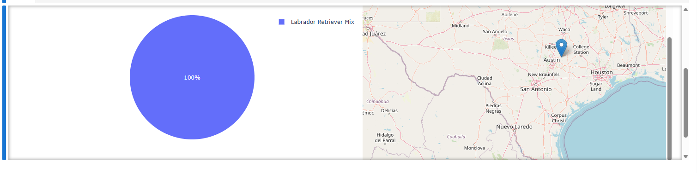
reset_1.png
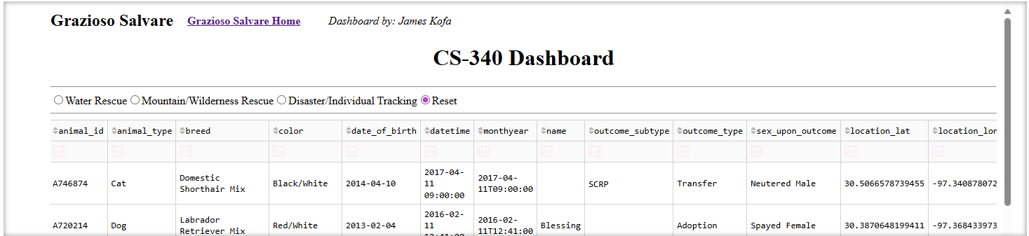
reset_2.png
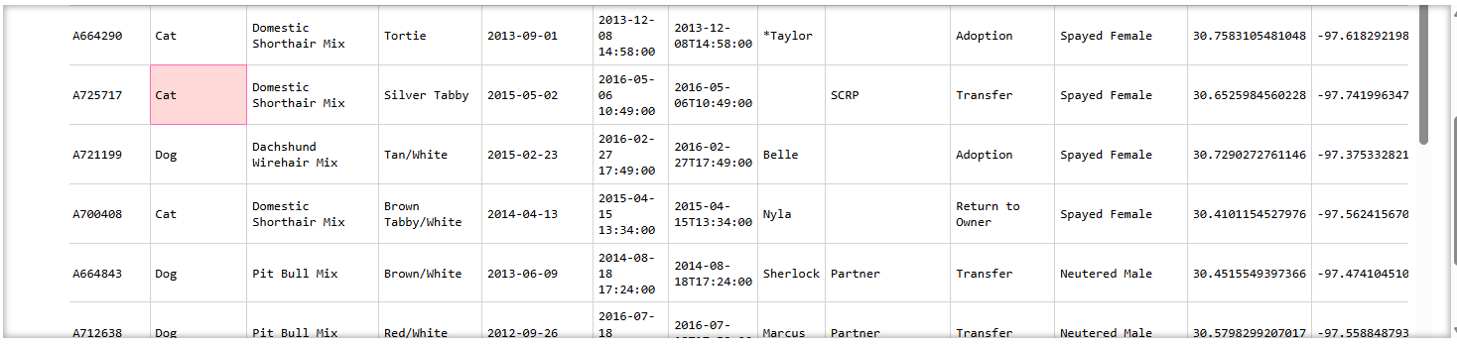
reset_3.png
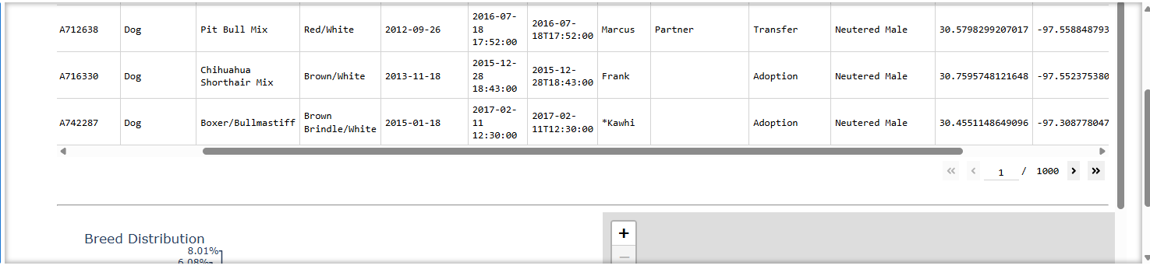
reset_4.png
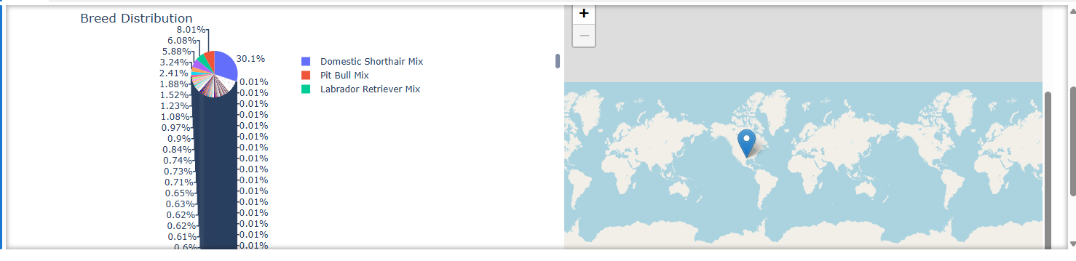
reset_5.png
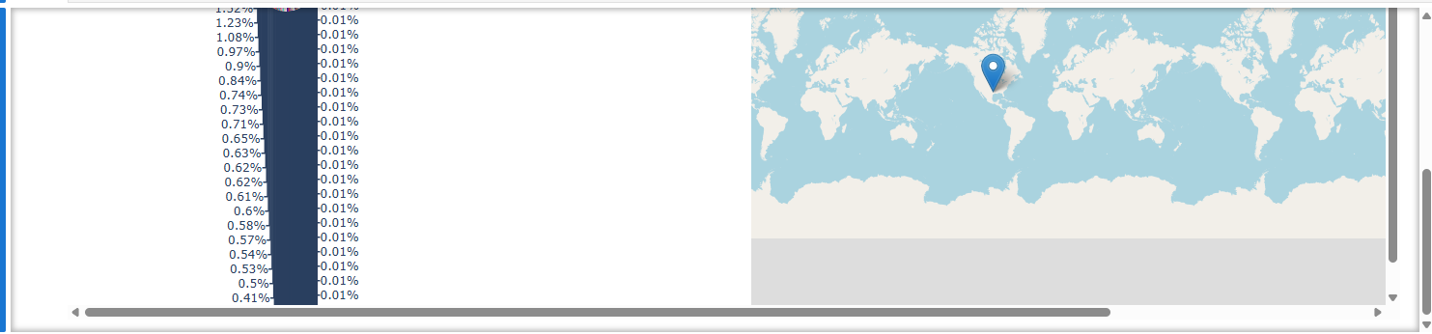
Summary
This document contains screenshots from the CS-340 Dashboard project. It includes filtered views for Water Rescue, Mountain/Wilderness Rescue, Disaster/Individual Tracking, and Reset states. Each section displays example table outputs, breed distribution charts, and map visualizations generated from the dashboard. This summary provides a high-level overview before the detailed screenshots.

